Say NO to fish passage and the 90 foot in stream dam on Johnson Creek. Please attend the public meeting Thursday, May 31, 2012,
7 to 9 PM at the Barn, 1200 11th St SW in Bandon. Everyone needs to help stop this!

- It is bad policy to destroy salmon habitat on one creek in order to restore salmon habitat on another creek, which is what is being proposed, to permanently destroy Johnson Creek's salmon habitat and do mitigation on Blair Creek instead. It is appropriate to restore both creeks.

- Johnson Creek's fish passage blockages (culverts and small dam) can be easily fixed, if they do not permanently seal off upper Johnson Creek with the proposed 90 foot in stream dam.

- This 90 foot in stream dam (1,556 acre feet of water) is inappropriate and dangerous in a geologically unstable zone and will endanger lives and property of those living below the proposed dam site.

- ODFW now has an in stream water right to protect fish habitat on Johnson Creek, and they have obligations to the public to do so. It is highly inappropriate for ODFW to be advocating for a fish waiver that would destroy salmon habitat on Johnson Creek.

- This 90 foot in stream dam is completely unnecessary. The City of Bandon does not need the water now that growth in Bandon is flat. Future water needs for farmers and the City can be met by other, less destructive means that do not harm the rights of nearby property owners. Thus, fish passage waiver is also unnecessary. The City of Bandon currently has an adequate supply of water for the next 20 years.

- The costs for this 90 foot in stream dam are very high for the small and uncertain benefits to a few people who subscribed to hypothetical water for this very expensive dam proposal. The engineering, the fish passage (or the mitigation, if the waiver is granted), the permits, and the actual construction costs will all be paid by taxpayers, especially the City of Bandon and the Bandon Cranberry Water Control District (BCWCD).

- It is questionable if BCWCD will ever be able to get the water rights it has applied for from the Water Resources Department, because WRD manages in stream rights on Johnson Creek for ODFW as a public trust, and that in
stream right is senior to the BCWCD applications.

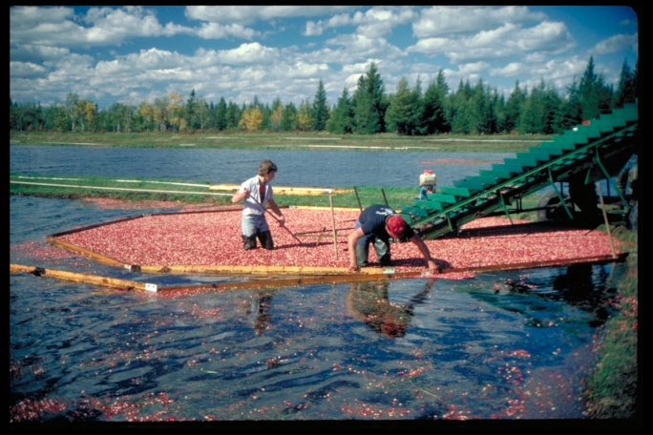

For more information contact Cameron at Oregon Coast Alliance, 503-391-0210

