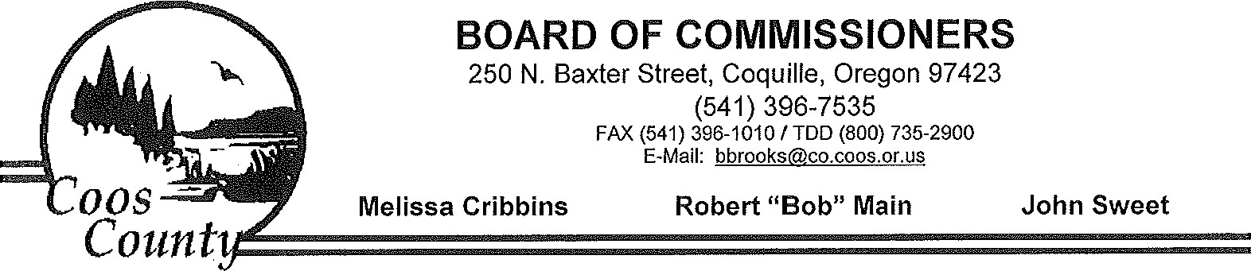
April 2, 2015
RE: SB 941 Opposition
We are writing in opposition to Senate Bill 941, a bill that requires private individuals to complete the transfer of a firearm by appearing with the transferee before a gun dealer to request a criminal background check. We would also question the emergency nature of this bill, which does not appear to address a tiue emergency, and the need for it to be effective on passage.
SB 941 creates an undue burden on citizens, particularly those in rural areas, who wish to sell or transfer a firearm to a nonfamily member. Coos County is a rural county, with a population of roughly 60,000 lives. This bill will force citizens of counties like ours to seek out a licensed gun dealer who is both open for business and willing to facilitate a transfer between private parties. In our geographically isolated counties, a willing facilitator may not be easy to find, or transferors may discover that the cost of a "reasonable" fee imposed by the gun dealer has a chilling effect on their ability to transfer firearms. This has the effect of imposing a tax on firearm owners.
Additionally, the background check process in the bill requires extensive information about the firearm be recorded, in essence creating a gun registry. While that may not be the intent of this legislation, it is troublesome for many of our citizens who do not trust that the govemment has their best interests at heart in creating such a registry.
Despite the controversial nature of SB 941, it is being fast-tracked for approval. At least one County Sheriff has stated that he will not enforce this law in his jurisdiction. Other law enforcement officials will likely concur. It is irresponsible to pass a controversial bill with no time to reach consensus among the counties about implementation and effect. At a minimum, it is appropriate and necessary to allow for more public testimony on this bill.
With such widespread concerns about this bill among our constituents, we must encourage you to oppose SB 941. SB 941 will burden rural Oregonians who will be forced to drive great distances and pay a fee to transfer ownership of firearms. Please join with us in opposing Senate Bill 941.
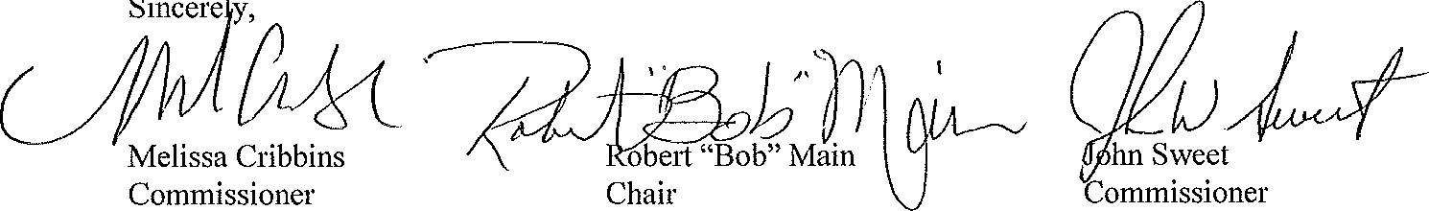
Sincere
y,
Coos County is an Affirmative Action/Equal Opportunity Employer and complies with section 504 of the Rehabilitation Act of 1973

